**PROGRAM 01 :**

student_marks = data.frame( # Create data frame

RollNo = c(1, 2, 3, 4, 5),

Sub1 = c(85, 78, 92, 67, 80),

Sub2 = c(75, 82, 88, 70, 79),

Sub3 = c(90, 85, 95, 72, 88)

)

print(student_marks) # Print the data frame

**OUTPUT :**

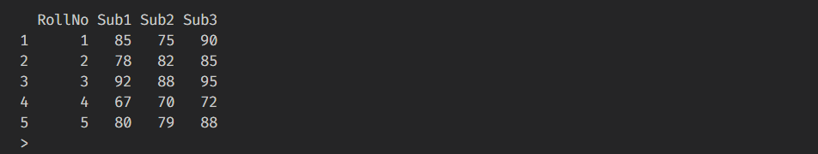

**PROGRAM 02**

**st**udent_marks = data.frame( # Create data frame

RollNo = c(1, 2, 3, 4, 5),

Sub1 = c(85, 78, 92, 67, 80),

Sub2 = c(75, 82, 88, 70, 79),

Sub3 = c(90, 85, 95, 72, 88)

)

# Box plot for each subject

boxplot(

student_marks[,2:4],

main="Boxplot of Marks Distribution",

xlab="Subject",

ylab="Marks",

names=c("Subject 1", "Subject 2", "Subject 3")

)

**OUTPUT :**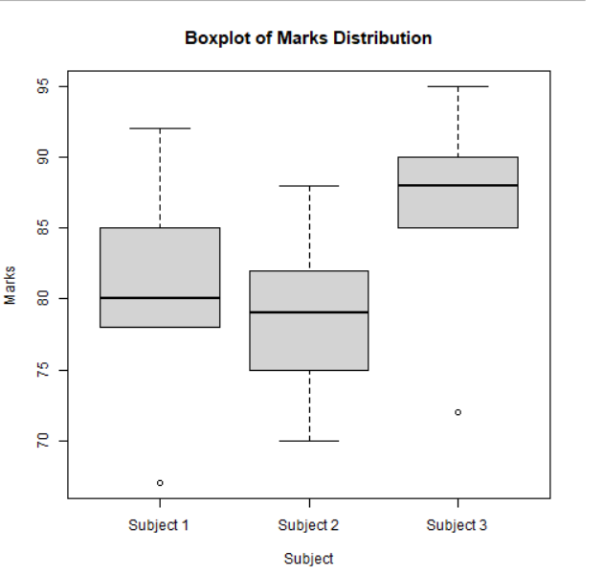

**PROGRAM 03 :**

student_marks = data.frame( # Create data frame

Sub1 = c(85, 78, 92, 67, 80),

Sub2 = c(75, 82, 88, 70, 79),

Sub3 = c(90, 85, 95, 72, 88)

)

# Plot histograms for each subject

hist(student_marks$Sub1,

main = "Subject 1 Marks",

xlab = "Marks"

)

hist(student_marks$Sub2,

main = "Subject 2 Marks",

xlab = "Marks"

)

hist(student_marks$Sub3,

main = "Subject 3 Marks",

xlab = "Marks"

)

**OUTPUT :** 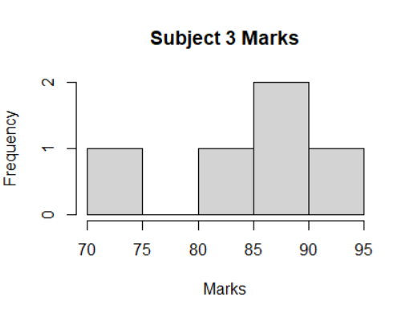

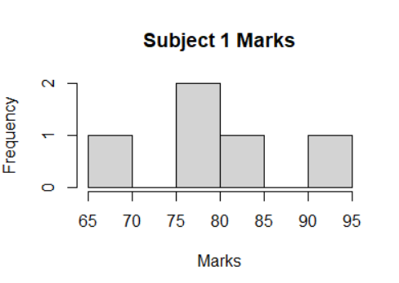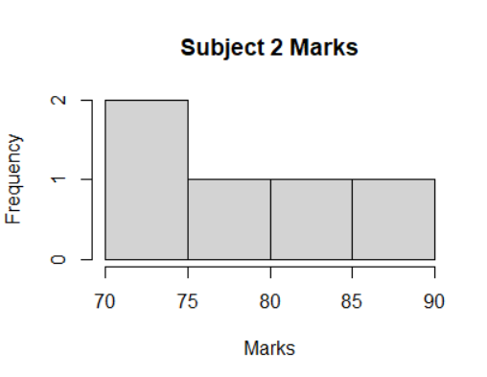

**PROGRAM 04 :**

student_marks = data.frame( # Create data frame

RollNo = c(1, 2, 3, 4, 5),

Sub1 = c(85, 78, 92, 67, 80),

Sub2 = c(75, 82, 88, 70, 79),

Sub3 = c(90, 85, 95, 72, 88)

)

# Summary statistics for each subject

summary_subject1 = summary(student_marks$Sub1)

summary_subject2 = summary(student_marks$Sub2)

summary_subject3 = summary(student_marks$Sub3)

# Print summaries

cat("Summary for Subject 1:\n")

print(summary_subject1)

cat("\n")

cat("Summary for Subject 2:\n")

print(summary_subject2)

cat("\n")

cat("Summary for Subject 3:\n")

print(summary_subject3)

**OUTPUT :**

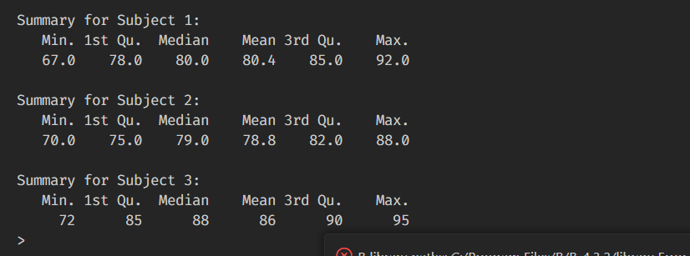

**PROGRAM 05 :**

student_marks = data.frame( # Create data frame

Sub1 = c(85, 78, 92, 67, 80),

Sub2 = c(75, 82, 88, 70, 79),

Sub3 = c(90, 85, 95, 72, 88)

)

cat("\n\nSubect 1 : ", student_marks$Sub1)

cat("\nMean : ", mean(student_marks$Sub1))

cat("\nMedian : ", median(student_marks$Sub1))

cat("\nRange : ", range(student_marks$Sub1))

cat("\nVar : ", var(student_marks$Sub1))

cat("\nStandard Deviation : ", sd(student_marks$Sub1))

q1 = quantile(student_marks$Sub1, 0.25)

q2 = quantile(student_marks$Sub1, 0.75)

IQR = q2 - q1

cat("\nIQR : ", IQR)

cat("\n\nSubect 2 : ", student_marks$Sub2)

cat("\nMean : ", mean(student_marks$Sub2))

cat("\nMedian : ", median(student_marks$Sub2))

cat("\nRange : ", range(student_marks$Sub2))

cat("\nVar : ", var(student_marks$Sub2))

cat("\nStandard Deviation : ", sd(student_marks$Sub2))

q1 = quantile(student_marks$Sub2, 0.25)

q2 = quantile(student_marks$Sub2, 0.75)

IQR = q2 - q1

cat("\nIQR : ", IQR)

cat("\n\nSubect 3 : ", student_marks$Sub3)

cat("\nMean : ", mean(student_marks$Sub3))

cat("\nMedian : ", median(student_marks$Sub3))

cat("\nRange : ", range(student_marks$Sub3))

cat("\nVar : ", var(student_marks$Sub3))

cat("\nStandard Deviation : ", sd(student_marks$Sub3))

q1 = quantile(student_marks$Sub3, 0.25)

q2 = quantile(student_marks$Sub3, 0.75)

IQR = q2 - q1

cat("\nIQR : ", IQR)

**OUTPUT :**

